Brainstorming: It’s All In There

When you are stuck in any point of the writing process, there are different techniques that you can use to spark inspiration. A common method is brainstorming. This is a great way to organize your thoughts and find your strongest and weakest points. There are no right or wrong brainstorming methods. Some examples include:
- Free write
- Organizational bubbles
- Asking/Answering Questions

Free Write
This method has no rules— anything goes. All this strategy requires is at least 5 minutes of your time— writing out what you currently know on your subject. For some, this could be organized in bullets. Others may just write all their current ideas as a large paragraph on a page. The purpose is to lay out all of your ideas in one place. This could be points that you want to make, questions you may have, or points you want to explore in your research. After the 5 minute free write, take another 5 minutes to organize the information you wrote. This can help you see where more information will be needed in your paper and what points you might not want to include. This is a great strategy that will help you find direction for your assignment.

Asking/Answering Questions
This method is a great way to start off your assignment. You can list questions from your prompt, questions you have about your topic that you want to explore, as well as questions your intended audience might have. After listing out questions, go back and answer what you can. Later you can elaborate on these question points to build them into your paper. This strategy does two things: 1) it shows where more research is needed, and 2) it helps you think of the purpose of your paper and what you want to address.

Organizational Bubbles
This method is great for organizing your thoughts into paragraphs. 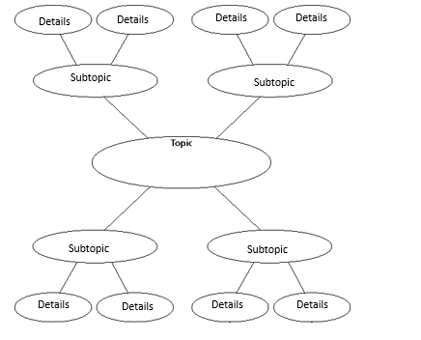
Above is a sample diagram layout for using this strategy. The central bubble is for the specific topic or question you have. The first level of bubbles extending from the central bubble are for your supporting subtopics you will be using in your paper, and the last set of bubbles is for the details that support the subtopics. The number of subtopic and detail bubbles is unlimited. This is a great tool for seeing the flow of ideas for your paper as well as where more support is needed.

